Diacel DB & Application process steps
There are two server in Diacel account as mentioned below.
- App-Server(Windows)
- DB – Server(Linux)
Steps to be followed to start the application:-
Step1:- Firstly login to DB server & check whether is running or not by using below command
Check whether the below ports 8000, 40000 are listening or not in DB server.
netstat –ntpl
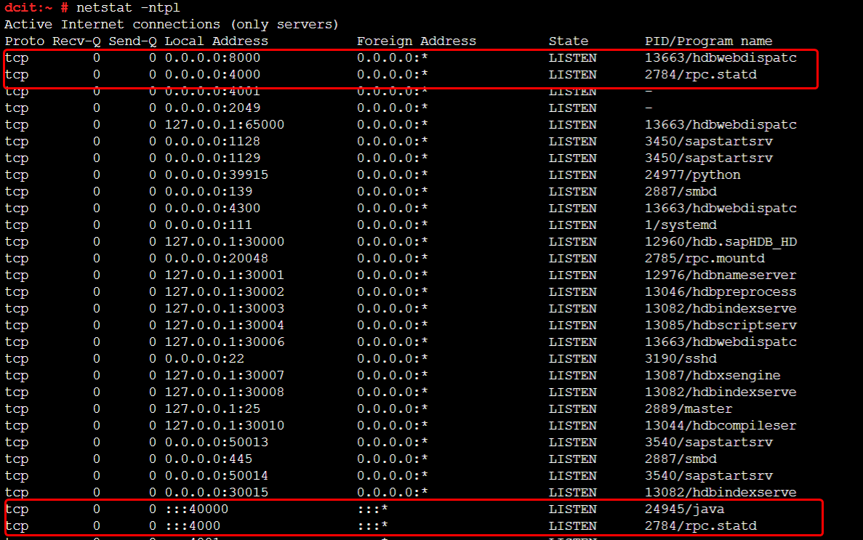

Before starting DB check the status and start it if not running with below command as mentioned below.
/etc/init.d/sapb1servertools status
/etc/init.d/sapb1servertools start
If it is fine, login as user:- hdbadm and then start the DB with below command.
- sudo su – hdbadm
- ./HDB start
- sapcontrol -nr 00 -function GetSystemInstanceList

After checking with above commands, logout from the DB .
Step2:- Login to windows server and got to services.msc and check whether the service “SAP Business One Browser Access Server Gatekeeper” is running or not.
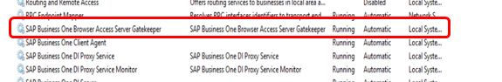
If not please start the above mentioned service.
Then got to browser and check with the URL:- https://13.232.168.135:8100/dispatcher/ and you will get one page as shown in screenshot below.
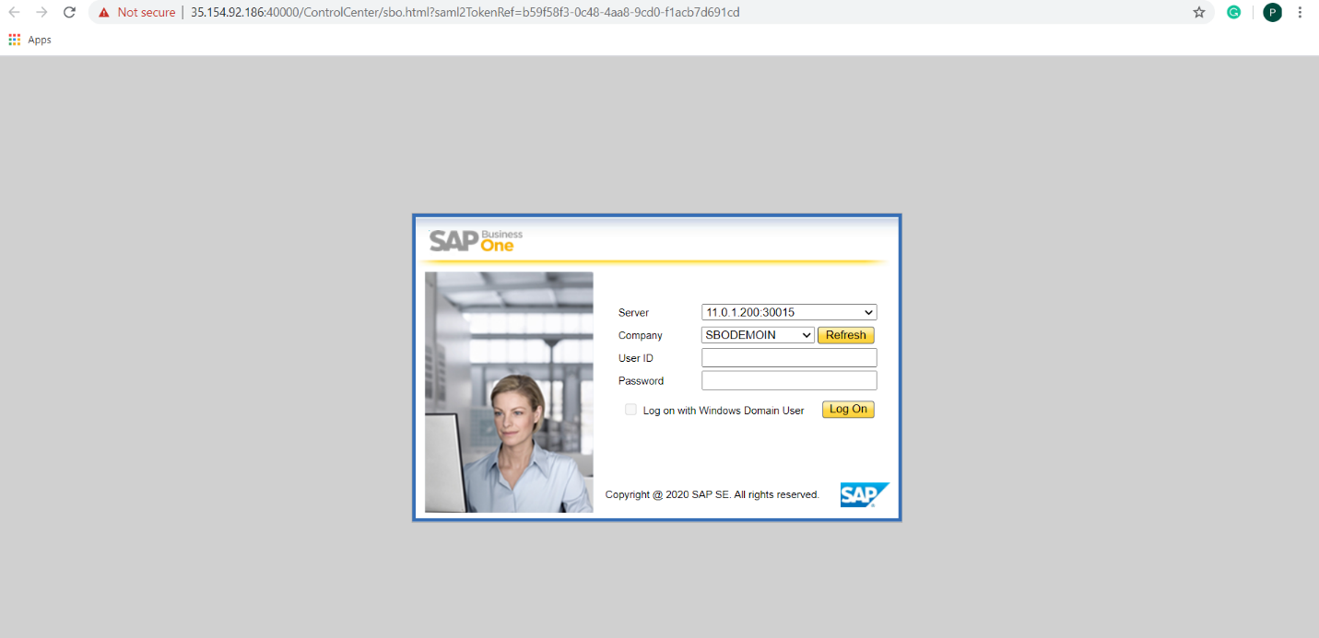
Note:- If client asks to restart the servers. First stop the DB server (Linux) & then App Server (Windows). While starting First start the DB server (Linux) and after 5-10 minutes start the App server (Windows).

